# Lab: Functions

Problems for in-class lab for the ["JS Fundamentals" course @ SoftUni](https://softuni.bg/trainings/2343/js-fundamentals-may-2019). Submit your solutions in the SoftUni Judge system at <https://judge.softuni.bg/Contests/1230/Functions-Lab>.

## Repeat String

Write a function that receives a **string** and a **repeat** **count** n. The function should return a new string (the old one repeated **n** times).

### Examples

|  |  |
| --- | --- |
| **Input** | **Output** |
| abc  3 | abcabcabc |
| String  2 | StringString |

### Hints

1. Firstly create a function and initialize the two parameters.  
   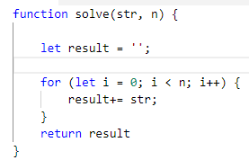
2. In the main function, print the result.

## Grades

Write a function that **receives a grade** between **2.00** and **6.00** and **prints** the corresponding grade in **words**

* 2.00 - 2.99 - "**Fail**"
* 3.00 - 3.49 - "**Poor**"
* 3.50 - 4.49 - "**Good**"
* 4.50 - 5.49 - "**Very** **good**"
* 5.50 - 6.00 - "**Excellent**"

### Examples

|  |  |
| --- | --- |
| **Input** | **Output** |
| 3.33 | Poor |
| 4.50 | Very good |
| 2.99 | Fail |

### Hints

## Math Power

Write a function that **calculates** and **returns** the value of a number **raised** to a **given power**:

### Examples

|  |  |
| --- | --- |
| **Input** | **Output** |
| 2  8 | 256 |
| 3  4 | 81 |

### Hints

* Create a function which will have **two parameters** - the **number** and the **power**, and will **return** a **result**.
* **Print** the result.

## Orders

Write a function that calculates the **total** **price** of an order and prints it on the console. The function should receive one of the following products: **coffee, coke, water, snacks**; and a **quantity** of the product. The **prices** for a single piece of each product are:

* coffee - 1.50
* water - 1.00
* coke - 1.40
* snacks - 2.00

Print the result **formatted** to the **second** **decimal** **place**.

### Example

|  |  |
| --- | --- |
| **Input** | **Output** |
| water  5 | 5.00 |
| coffee  2 | 3.00 |

### Hints

* Create a function and pass the two variables in.
* Print the result in the method.

## **Simple** **Calculator**

Write a function that receives **three parameters** and write an **arrow** **function** that calculate result depending of operator. Operator can be **'multiply'**, **'divide'**, **'add'**, **'subtract'**.

### Input

The input comes as parameters named **numOne,** **numTwo,** **operator**.

### Examples

|  |  |
| --- | --- |
| **Input** | **Output** |
| 5  5  'multiply' | 25 |
| 40  8  'divide' | 5 |
| 12  19  'add' | 31 |
| 50  13  'subtract' | 37 |

### Hints

* Use switch statements for the different operators.

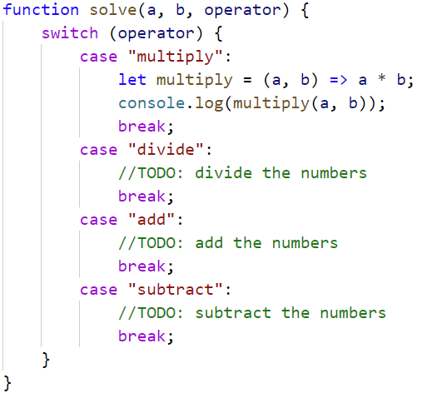

## Wrong Result

You are given a function, that calculate the result of **numOne * numTwo * numThree** (the product) is **negative** or **positive**.

Try to do this **WITHOUT** multiplying the 3 numbers.

The input comes as parameters named **numOne,** **numTwo,** **numThree**.

### Example

|  |  |
| --- | --- |
| **Input** | **Output** |
| 5  12  -15 | Negative |
| -6  -12  14 | Positive |
| -1  -2  -3 | Negative |
| -1  0  1 | Positive |

### Hints

* Check all the different variantions for the three numbers.

